|  |
| --- |
| Circle Language Spec: Inheritance |

## System Command Overriding

Overriding was already introduced before, but what is separately mentioned here is that you can override any of the system commands. You can for instance override the Value Set command.

A lot of notations were considered but many were complicated or ambiguous. Easier alternatives are adopted here.

Here are the two alternatives to a notation for overriding system commands:

*The event notation*

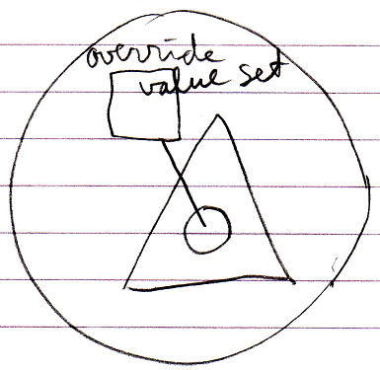

*System interface with object redirection*

